Set Tayo ng Date
Analysis Model

Submitted to:

Asst. Prof. Ma. Rowena C. Solamo
Faculty Member
Department of Computer Science
College of Engineering
University of the Philippines, Diliman

Submitted by:
Bandong, Arvin
Bariring, Edward James
Rosales, Kyle

In partial fulfillment of Academic Requirements
for the course
CS 191 Software Engineering I
of the
1st Semester, AY <2016-2017>

Revision Control

History Revision:
Revision Date | Person Responsible | Version  Number | Modification
10/20/2016 | Kyle Rosales | 1.0 | Initial document, list of boundaries, controllers, and entities
10/21/2016 | Arvin Bandong | 1.2 | Class Diagram
10/21/2016 | Edward James Bariring | 1.3 | Added class descriptions, other document information

Purpose:

This document will serve as the guide for which the readers will see the classes which will be used for the software.

Audience:

Target audience for this document will primarily be the developer although the user can also refer to it if they have interest.
System Name: Set Tayo ng Date

Description: This software allows people in a group to input their schedules into the software's database. It is a tool to help people set meetings when everyone in the group is free by displaying everyone's schedules.

Class Diagram:

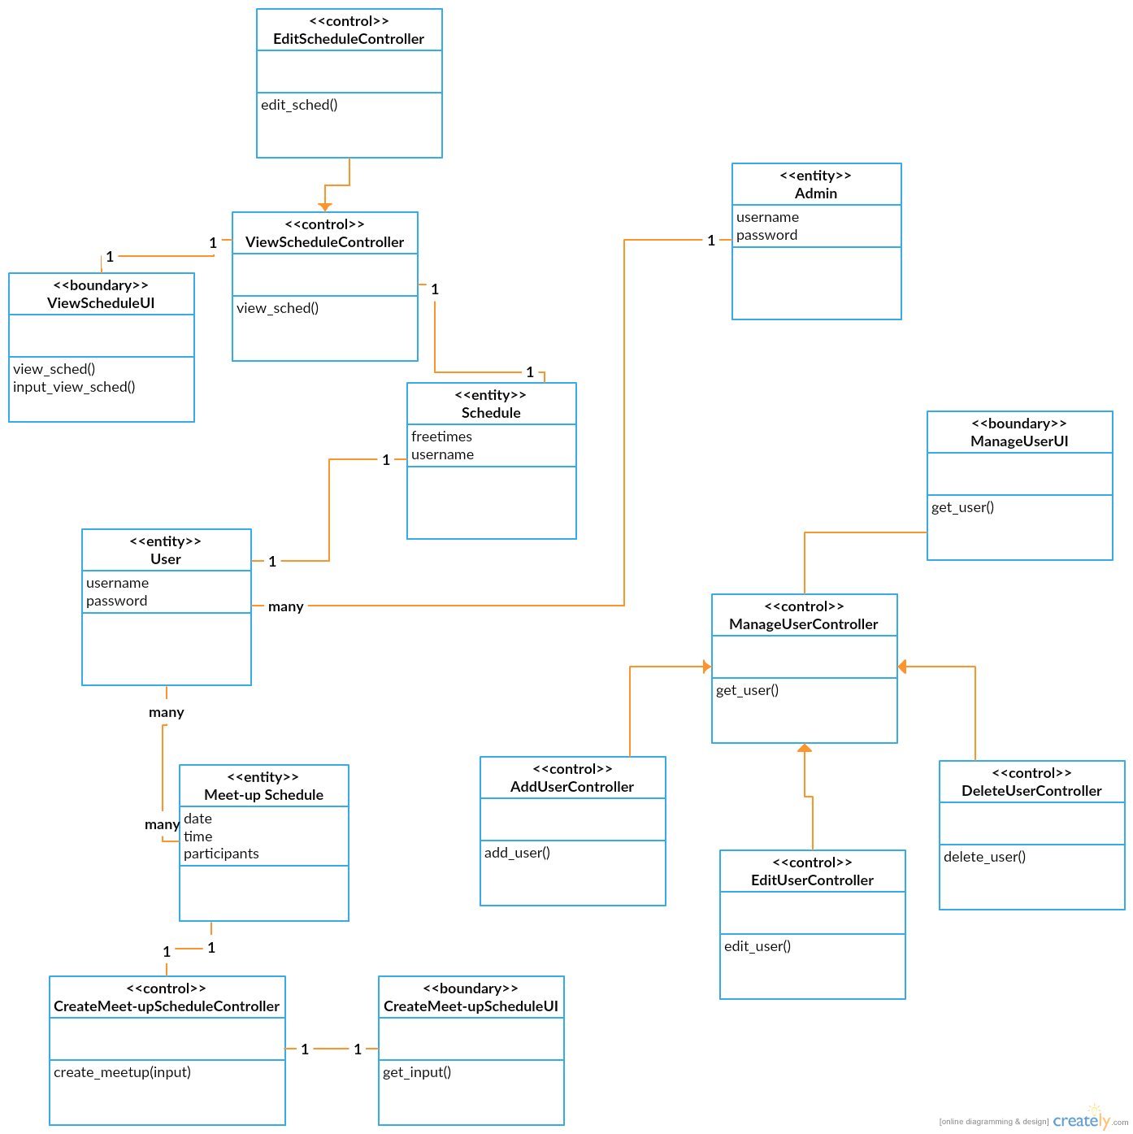

Boundary Classes:

Class Name | Description
ViewScheduleUI | This will bring up the schedule to be viewed by the user
CreateMeetupScheduleUI | This will bring up the finalized schedule to be viewed by the user
ManageUserUI | This will bring the schedule of the user to be managed by user himself

Control Classes:

Class Name | Description
ViewScheduleController | retrieves the user schedule from the database and passes it to the boundary class
EditScheduleController | gets input from the boundary class and edits the schedule in the database then saves changes
CreateMeetUpScheduleController | gets input from the boundary class and creates an entry in the MeetUpSchedule table in the database
ManageUserController | gets the entries in the Users table and sends it to the boundary class for the admin
AddUserController | gets input from the boundary and adds an entry in the User table
DeleteUserController | gets input from the boundary and deletes an entry in the User table
EditUserController | gets input from the boundary and edits an entry in the User table

Entity Classes:

Class Name | Description
Admin | Manages user database
User | User can add his/her own schedule to the database for future use
Schedule | Time where a user is free
MeetUpSchedule | Time where all concerned users are free

